Lab Task – 5

a) Implementation the following operations: enqueue, dequeue and finding an element:

1. Linear Queue using arrays::

Ans:-

#include<stdio.h>

#include<stdlib.h>

#define n 5

int q[n];

int f=-1,r=-1;

void enqueue()

{

int d;

printf("enter the element to insert:");

scanf("%d",&d);

if(r==n-1)

{

printf("overflow");

}

else if(r==-1&&f==-1)

{

f=r=0;

q[r]=d;

}

else

{

r++;

q[r]=d;

}

}

void dequeue()

{

if(f==-1&&r==-1)

{

printf("underflow");

exit (1);

}

else if(f==r)

{

printf(" deleted element is %d\t\n",q[f]);

f=r=-1;

}

else

{

printf(" deleted element is %d\t\n",q[f]);

f++;

}

}

void find()

{

int i,j,k=0;;

printf("enter the element to search:");

scanf("%d",&i);

for( j=f;j<=r;j++)

{

if(q[j]==i)

{

k=1;

break;

}

}

if(k==1)

printf("element is found");

else

printf("element not found");

}

int main()

{

enqueue();

enqueue();

enqueue();

dequeue();

find();

return 0;

}

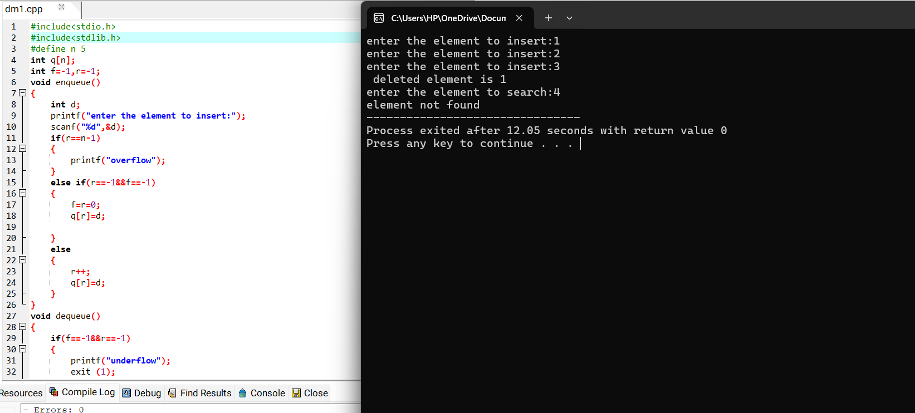

2)Circular queues::

ANS:-

#include<stdio.h>

#define n 5

int q[n];

int f=-1,r=-1;

void enqueue()

{

int d;

printf("enter the element to insert:");

scanf("%d",&d);

if(f==-1&r==-1)

{

f=r=0;

q[r]=d;

}

else if(((r+1)%n)==f)

{

printf("\n overflow");

}

else

{

r=(r+1)%n;

q[r]=d;

}

}

void dequeue()

{

if(f==-1&&r==-1)

{

printf("underflow");

}

else if(f==r)

{

printf("deleted element is %d\n",q[f]);

f=r=-1;

}

else

{

printf("deleted element is %d\n",q[f]);

f=(f+1)%n;

}

}

void find()

{

int i,k=0,s;

printf("enter the element to search:");

scanf("%d",&s);

for(i=f;i!=r+1;i=(i+1)%n)

{

if(s==q[i])

{

k=1;

break;

}

}

if(k==1)

printf("element is found");

else

printf("element is not found");

}

int main()

{

enqueue();

enqueue();

enqueue();

enqueue();

dequeue();

find();

return 0;

}

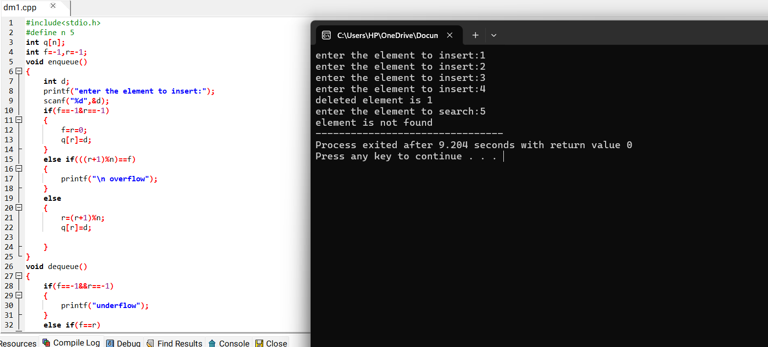

b) Assignment-2: The “4-Queens Problem” consists of placing four queens on a 4 x 4 chessboard so that no two queens can capture each other. That is, no two queens are allowed to be placed on the same row, the same column or the same diagonal (both primary and secondary diagonals).  Write a C program to simulate the given problem and perform the algorithmic complexity analysis for the solution you propose.

ANS:-

#include <stdio.h>

#define N 4

int board[N][N];

void printSolution() {

for (int i = 0; i < N; i++) {

for (int j = 0; j < N; j++)

printf("%d ", board[i][j]);

printf("\n");

}

printf("\n");

}

int isSafe(int row, int col) {

for (int i = 0; i < col; i++)

if (board[row][i])

return 0;

for (int i = row, j = col; i >= 0 && j >= 0; i--, j--)

if (board[i][j])

return 0;

for (int i = row, j = col; j >= 0 && i < N; i++, j--)

if (board[i][j])

return 0;

return 1;

}

int solveNQueens(int col) {

if (col >= N) {

printSolution();

return 1;

}

int res = 0;

for (int i = 0; i < N; i++) {

if (isSafe(i, col)) {

board[i][col] = 1;

res = solveNQueens(col + 1) || res;

board[i][col] = 0;

}

}

return res;

}

int main() {

for (int i = 0; i < N; i++)

for (int j = 0; j < N; j++)

board[i][j] = 0;

if (!solveNQueens(0))

printf("Solution does not exist\n");

return 0;

}

